**Analyst Report**

1.1

Assumption--------------1.1

For this project, there are some assumptions that we need to consider to include the desired features and functionality before starting the development of the project. These will include:

* Display of courses being offered – The “Academics & Degrees” tab will display various links such as “Undergraduate Degrees” and “Graduate Degrees” that are on offer by the university. It will also provide links to other related information such as “Course Catalog,” “Student Opportunities,” “Support” and “Resources.” Any new courses or changes in course details or curriculum will be adequately updated by university staff or faculty.
* Research undergoing currently – The “Center for Research & Scholarship” page will showcase all research related info in regards to Liberty University for the user. This will be updated accordingly by the research teams involved by logging into their accounts and submitted information to be published in this section.
* News – Under the “About Liberty” tab, there will be a link called “News & Events” which will display university news and also instances of Liberty University being in the news. Current students and university staff and faculty will be able to submit the latest updated news after they log in to their accounts, which will be published on this page.
* Success stories of previous students – The “Alumni” tab at the top of the page will direct user to “Alumni Relations” page, which will contain all information pertinent to previous students. It will also allow search for alumni who previously studied at Liberty University. Previous students can register and create a profile for themselves which will help potential new students with their decision making.
* Information about the university – The “About Liberty” tab will reveal a link to “History of Liberty” which will direct the user to information regarding the founder, history of Liberty and also university timeline. It is important for students and their parents to know the heritage of the university as it will help inspire them. They will be able to view the exact timeline in a storytelling format to help understand this better.
* Contact details – The “Contact Liberty” link under the “About Liberty” tab will show phone numbers and email addresses to various departments of the university. It will present users with contact details. Additionally, the “Visit Liberty” link also under the “About Liberty” tab will provide users with a virtual tour or a chance to video chat.
* Enquiries – When the user scrolls down slightly, the bottom of the page will contain a link for them to “Request Info” with a question mark logo. After user clicks this link, they will be directed to a page which contains a form. User can fill in this form and request for information and produce enquiries to ask the university. The university staff or faculty will be notified and they will answer to these enquiries.

1.2

User stories------------1.2

|  |  |
| --- | --- |
| **No.** | **Item** |
| 1 | As a parent, I want to view all the different courses offered by Liberty University with course details to help my child choose the course they like. |
| 2 | As a visitor, I want have a look at the current student research done at Liberty University. |
| 3 | As an aspiring new student, I want to see success stories of previous students for inspiration and motivation. |
| 4 | As a staff member, I want to be able to post news and events in order to show up to date information regarding what happens inside the university. |
| 5 | As a faculty member, I want the website to show the history of Liberty University to the general public. |
| 6 | As a current student, I want to clear all my doubts and questions from a page of enquiry where I can ask about the course I am going to enroll in. |
| 7 | As a staff member, I want to modify student data and be able to keep an updated record of this. |
| 8 | As a student before enrolling in a course, I want to view all the detailed admission and tuition fees information from the website. |
| 9 | As a student who is interested to visit Liberty University, I want to obtain contact information and to see a map showing the location information on the website. |
| 10 | As a current student, I want to see my previous exam results online without having to print them out on paper. |
| 11 | As a parent, I want to see latest information regarding COVID-19 and how Liberty University is trying to tackle the current situation on the website. |
| 12 | As a faculty member, I want to edit course details and submit class schedule online. |
| 13 | As a faculty member, I want to submit student grades and upload lecture material. |

1.3

Use Case Diagrams-------1.3

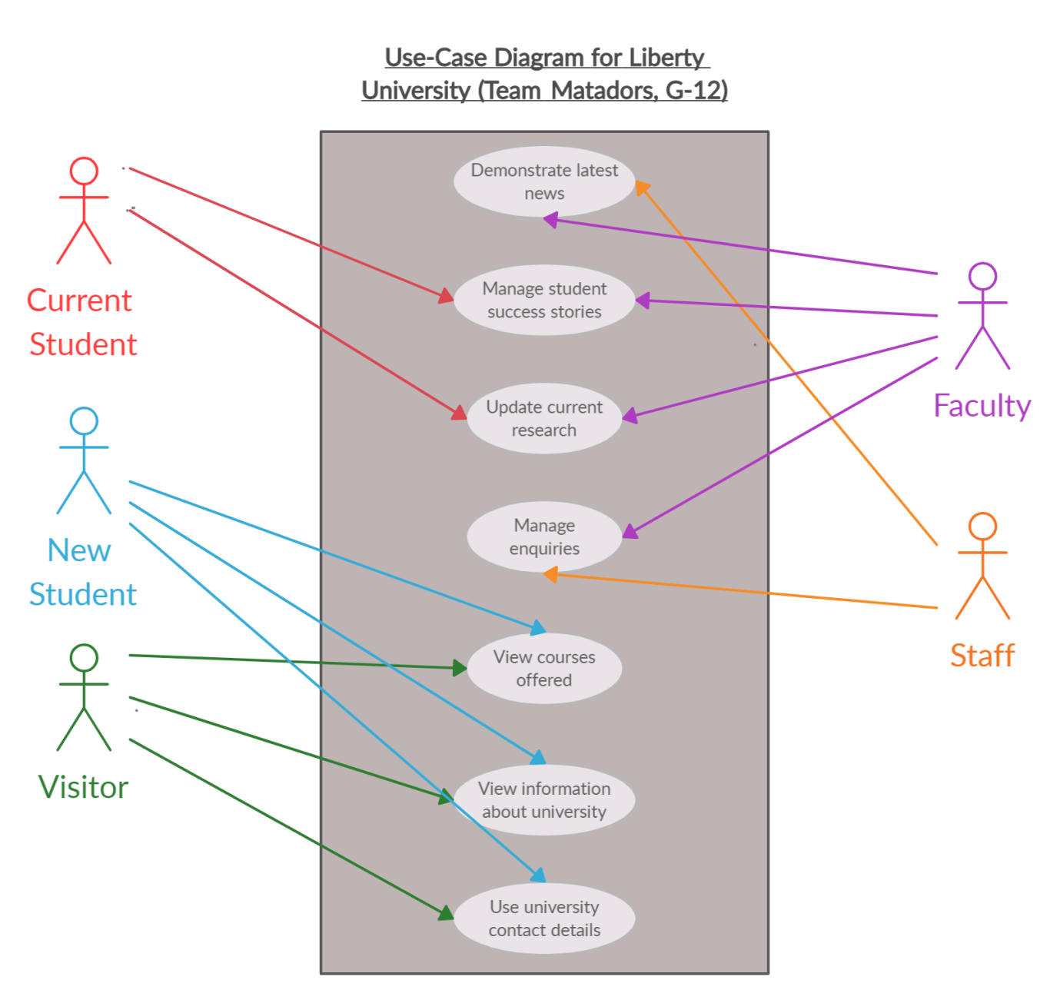

1.4

Workflow----------------1.4

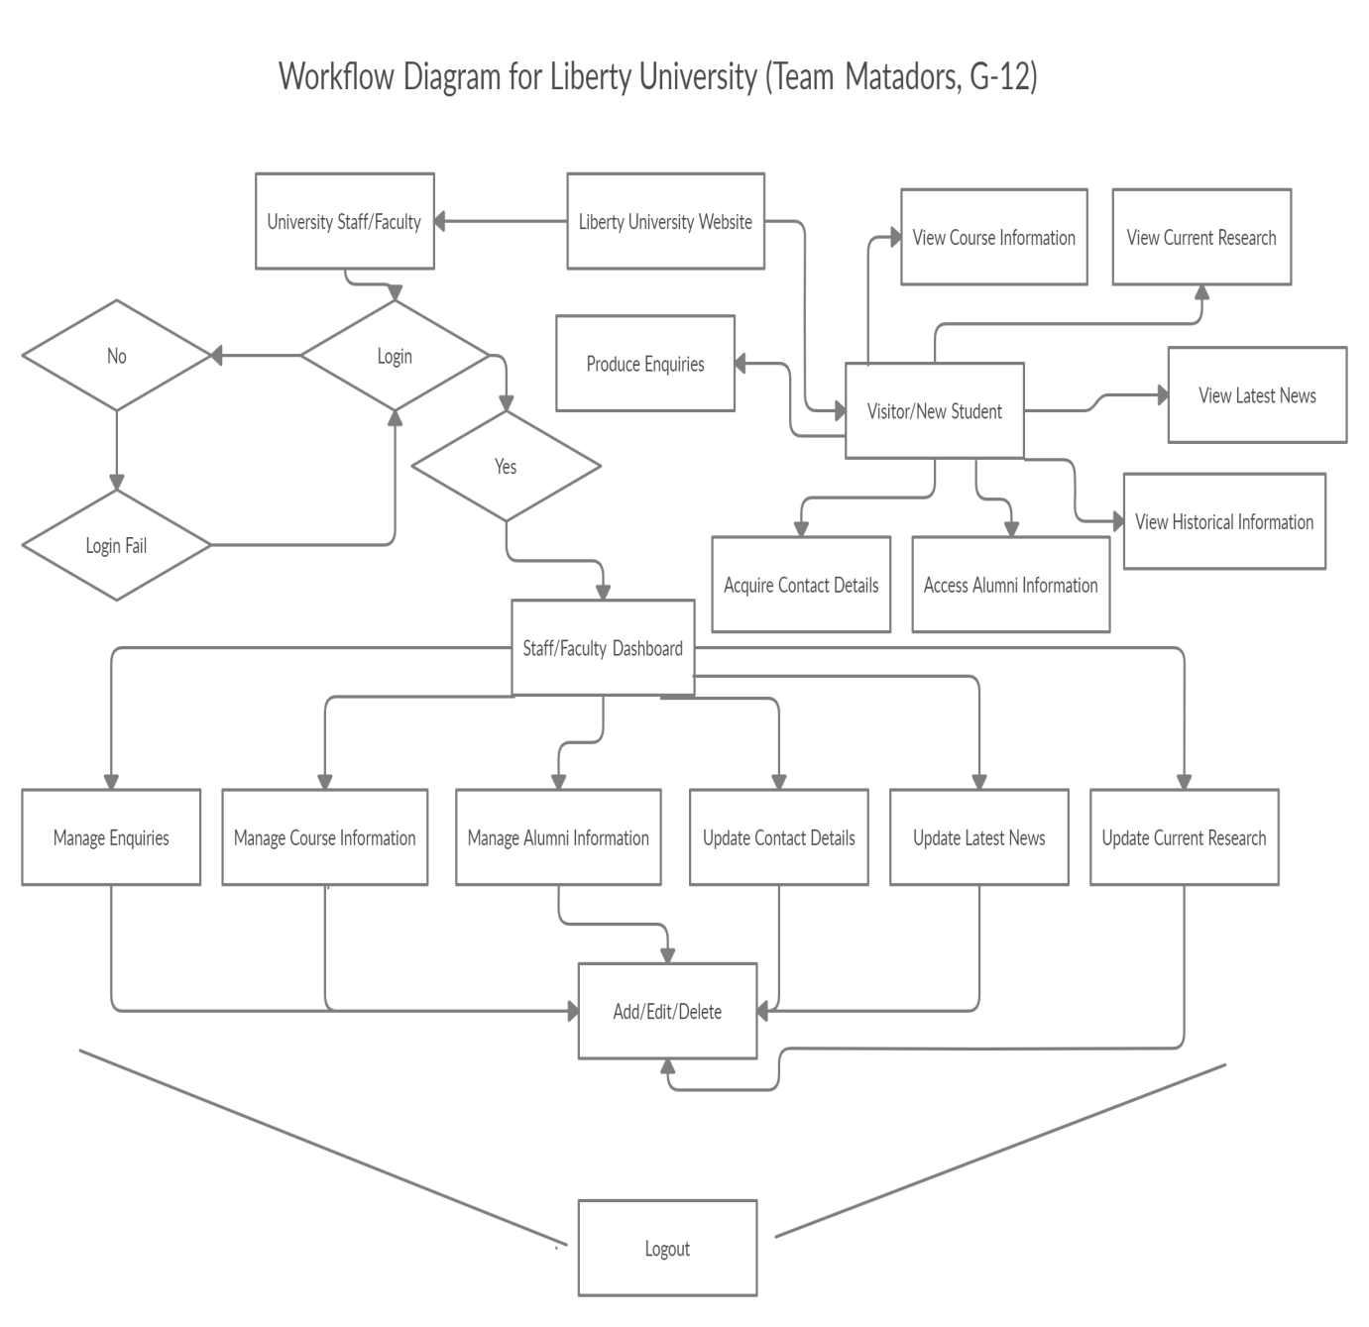

1.5

Initial Class Diagram---1.5

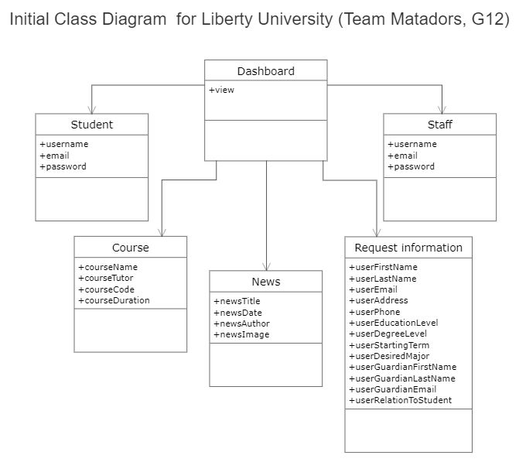

1.6

ERD---------------------1.6

